DIS-Afr-Kongo-N’kisi-Kuba Bwoom-Connection

*N’kisi* (plural, *miN’kisi*), a container or object in which medicines (*bilongo*) have been incorporated into or applied to in order to make it potent, is intimately associated with Kongo kingdom origins ca. 1100 AD/CE and the BaKongo (sing., Kongo) people as a whole (in modern western Democratic Republic of the Congo (formerly Zaire) and Congo and Angola.

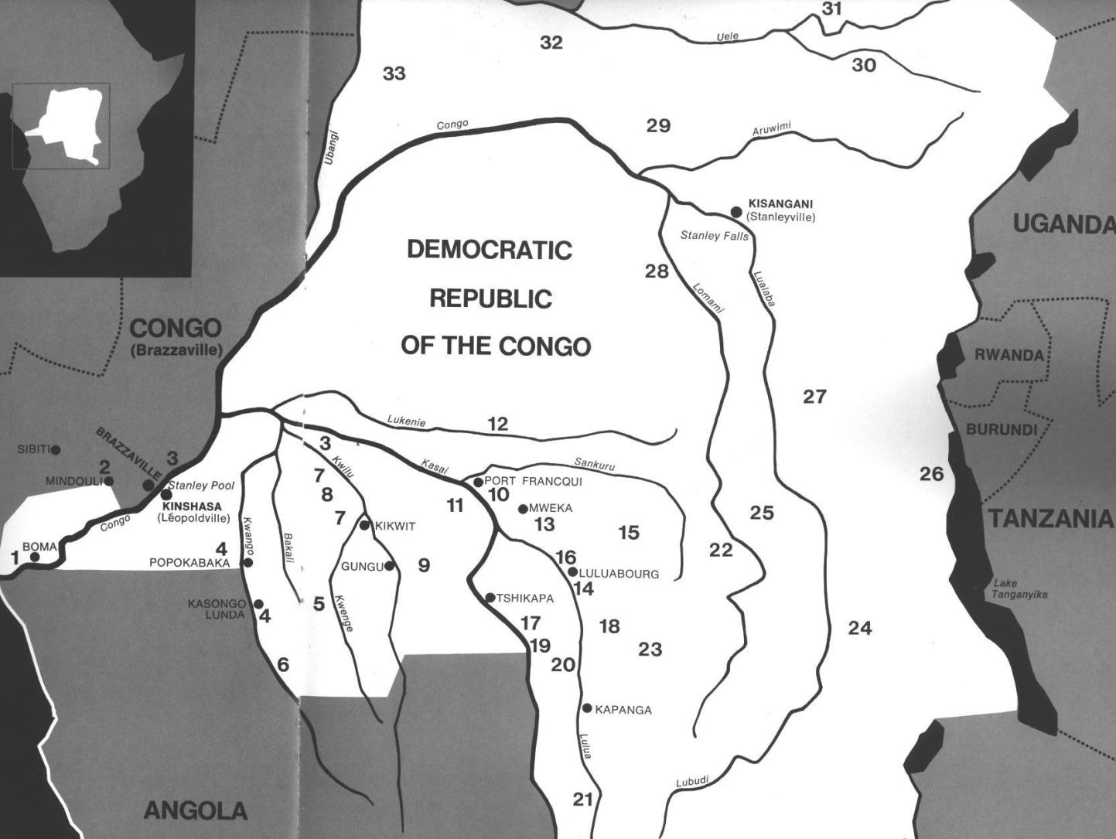

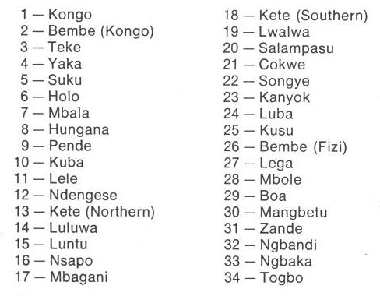

Fig. 1. Map of Kongo Cultures, West Central Africa.

1. Formation of the Kongo Kingdom

Around 1100 AD**/**CE Ntinu Lukeni (or Weni, son of a local king) in the Bantu Kongo-speaking Vungu (Bungu) Kingdom on the north bank of the Congo or Nzadi River (a truncation of thr KiKongo *nzadi o nzere*, "river swallowing rivers" (Forbath 1977;19). The Vungu, a Bantu-speaking group, invaded the south bank of the Nzadi River. There Ntinu Lukeni set up a system of tariffs , charging traders on the river a percentage of their goods. In addition he set up a series of treaties between his men and the local tribes to ensure that his governors married the daughters of the local chieftains, thereby ensuring a Kongo lineage. He further required all those along the river to speak the Kongo language. Among these peoples were three groups of diminutive, aboriginal inhabitants (BaMbaka-mbaka, Mbwidi-Mibodila and BaFula Mengo) that were characterized as having hydrocephaly (large heads), which physically and symbolically referred to their profound knowledge of the riches of the forests in which they lived and the medicines they derived from local plants. This knowledge was deemed important for the developing Kongo Kingdom and was observed at the courts of Mbanza Kongo and Loango where the King of the Kongo entertained the chief medical specialists of the Kingdom who regarded the aboriginal inhabitants of the Kingdom south of the Nzadi or Congo River as, in fact, pygmies.

Kuba-Bushongo -Bushoong Kuba

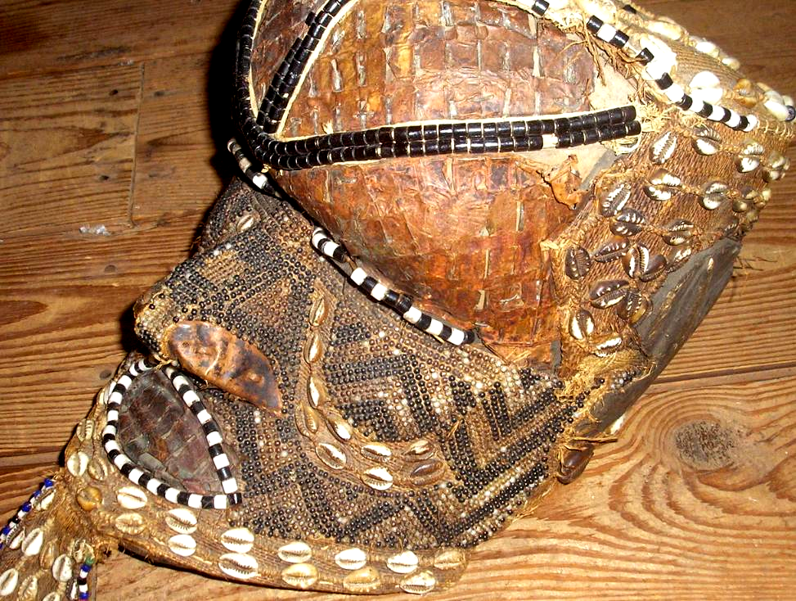

Fig. 2. *Bwoom* helmet mask, Kuba-Bushongo-Bushoong; Democratic Republic of Congo, Atlantika Collection. Wood, hammered copper, fiber, animal skin, cloth, beads, cowrie shells. This large proportioned hollow mask probably dates to the early twentieth century. The perimeter, temples, pate and back are decorated with beads and cowrie shells. A pendant beard has cowrie shells surrounded by beads. The broad face has an incised zigzag motif similar to the geometric keloids or tattoos that are applied to the Kuba body and which are replicated in textile designs (Cornet 1982:266; see Fig. 3). The cheeks are outlined with dual bands of cowrie shells, and the crown is covered with animal skin surmounted by three bands of two strand ancient beads.

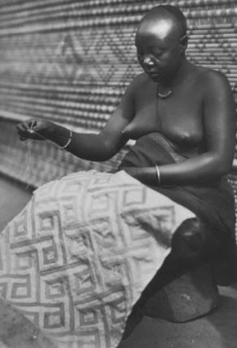

**Fig. 3, Kuba woman with geometric textile design emulative of zig-zag keloid tattoos that suggests the cultural connections of the Kuba with the Pygmy** (after [http://www.ezakwantu.com/Kuba%20Shoowa%20Zagourski.jpg](http://www.ezakwantu.com/Kuba Shoowa Zagourski.jpg)). (Note: I have used the term "Pygmy" here for the sake of simplicity, although I am aware of its non-African origin and its negative connotation in African contexts.)

The dark beads alternating with white beads at the temples suggest ethnic tattoo patterns (Cornet 1982:266), and the swastika design at the back of the head is one associated with royalty. Unlike other Kuba masks such as the *Mwaash* *a Mbooy*, which is usually interred with its owner, the *Bwoom* may be inherited, so it is not unusual to find old *Bwoom* masks being employed by younger dancers. This mask dates to the early-mid-20th century.

In this example, the carved wood understructure is covered with copper sheeting that is extended by a beard made of hide and accented throughout by beadwork. The contours of both the eyes and the mouth are also embellished by beads. A series of bead bands crosses the surface of the face, one from the crown of the head to the tip of the nose and another from one side of the head to the other, bisecting the eyes.

Tradition relates how Kuba masking was first introduced by a woman who carved a face on a calabash, the original model for initiation masks. Later, the invention was adopted into male initiation rites, and today remains a male privilege. Once Kuba boys enter the *nkan* initiation shelter, they are permitted to wear *Bwoom* masks and make excursions into the village frightening women and small children. More powerful masks are worn by initiation officials. Once masked, the Kuba dancer assumes the persona of the spirit of the mask and is indeed its apotheosis (cf. Torday 1910:250; Vansina 1955:140).  
The Bwoom mask proper dates to about the middle of the eighteenth century. An eighteenth-century song for the son of King Kot aNce refers to the first instance of adorning Bwoom masks with cowries and beads., implying that earlier masks were devoid of these accoutrements. Many variations of the mask evolved perhaps from a prototype (Vansina 1978: 216).

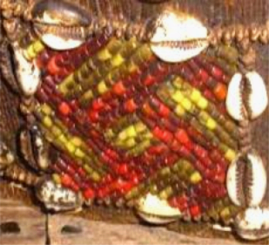

Right-handed Swastika design at the back of the head on the Atlantika Mboom mask.

The Bwoom mask has three aspects: 1) as a Pygmy, 2) as a challenging brother, and 3) as a common man.

1) The Bwoom as a Pygmy. The Pygmies are forest-dwelling, hunter-gatherers and know this seemingly impenetrable landscape intimately. The ancient idea that a society's landscape is its own because its ancestors are buried there is central to Pygmy cosmology. The kuba recognized this ancient idea. When they migrated into Pygmy forests they realized that their hope of a successful life in this landscape was to ally themselves with the Pygmies and learn the Pygmy lore of the ancient ancestral forest spirits (cf. Ehret 2002:50; Schadeberg 1999). Appropriately, *Bwoom* is the first spirit seen as an apotheosis by *nkan* initiates.

2) The Bwoom as the challenging brother. This aspect of the *Bwoom* invokes a ritual reenactment of the struggle for social power of the challenging brother who seeks both the throne of his brother, Mwaash A Mboy, and the king's wife, Ngaady A Mwaash. Bwoom, therefore, supports the challenge of authority.

3) The Bwoom as the common man. This role of the *Bwoom* fostered the respect of the individual's rights and the need for consensus among commoners as necessary checks and balances to offset royal authority.

The Bwoom is one of three royal mask types: 1) ***Mwaash a Mbooy***, representing Woot and the king; 2) the wooden face mask, **Ngady *Mwaash a Mbooy***, the incestuous sister-wife of Woot; and 3) the wooden helmet mask, ***Bwoom***, the Pygmy, challenging brother and common man. These characters appear in a variety of contexts including public ceremonies, rites involving the king, and initiations. Although their dances are generally solo, together the three royal masks re-enact Kuba myths of origin (Cornet 1982:254,256; Roy 1979:170).  
  
Two traditions trace *Bwoom*'s origin to the problem of royal succession: King Miko mi-Mbul killed the children of his predecessor so that he could succeed to the throne. However, he subsequently went mad. Even today the issue of royal succession is critical to West and Central African peoples as the slaughter at Yendi in northwestern Ghana illustrates in 2004 when the king of Yendi killed the offspring of his rival in Tamale. Although King Miko mi-Mbul eventually regained sanity, he would lapse into madness each time he wore the *Mwaash a Mbooy*, the sole royal mask. A Pygmy, an outsider who by his small stature was considered even less a a force than a kuba commoner, offered the king a *Bwoom* mask as a gift, and Miko accepted it. Its effects were profound, yet covert. With the *Bwoom* mask the king became like those whom he had previously despised. He learned empathy. Another version is that King Miko mi-Mbul, who was known as a great dancer, was seduced by the Pygmy's mask because the King Miko mi-Mbul danced with it so well in the rites, despite its overtly humble character. The king was able to enter the soul of the commoners and therefore perceive their innermost desires for a just rule. In order to soften the critique of royal malfeasance, in both versions the King is reputed to have made alterations to the mask that justified its inclusion in the royal repertoire (Cornet 1982:269). These accounts reify the need for royal power to be circumscribed (literally) by commoners "of low standing scarcely worthy of being embodied by the king" (Cornet 1975: 89). The defiant performance of *Bwoom* opposes the regal *Mwaash a Mbooy*. The two act out a competition for one female in the royal mask trio, Ngady mwaash aMbooy (Cornet 1982:255). Mwaash aM-booy's dance is calm, stately and without passion, while *Bwoom* acts with pride and passion (Cornet 1982:255). Materially, the masks are easily differentiated by material, for *Bwoom* is carved from a single piece of wood by male artisans and *Mwaash a Mbooy* is woven by women from textiles. Here a tension and quasi contradiction is implicit: the mask of commoners is manufactured by commoner men and the mask of royalty is manufactured by women ostensibly the consorts of the king. *Bwoom* appears apotropaically on the *nkan* "initiation fence" of the Kuba, prohibiting all not in the rite to enter (Vansina 1955:150-151). *Bwoom* does not appear at funerals and is never interred with the king or other dignitaries because it is the spirit of the living commoners not of the king (Cornet 1982:270). The costume is similar to that of *Mwaash a Mbooy*: heavy with profuse layers of raffia-cloth, bead and cowrie decoration, leopard skins, anklets, armlets, and fresh leaves. Eagle feathers or other prestigious media are added to the crown of the head when the mask is danced.

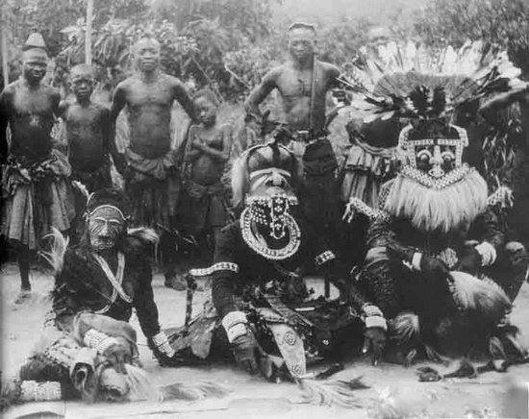

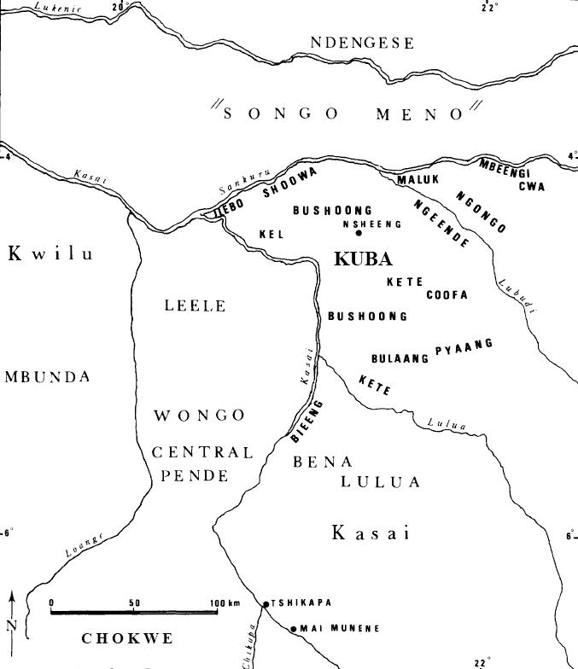

Kuba territory with tribal groups in bold typeface (after Brett-Smith 1983).

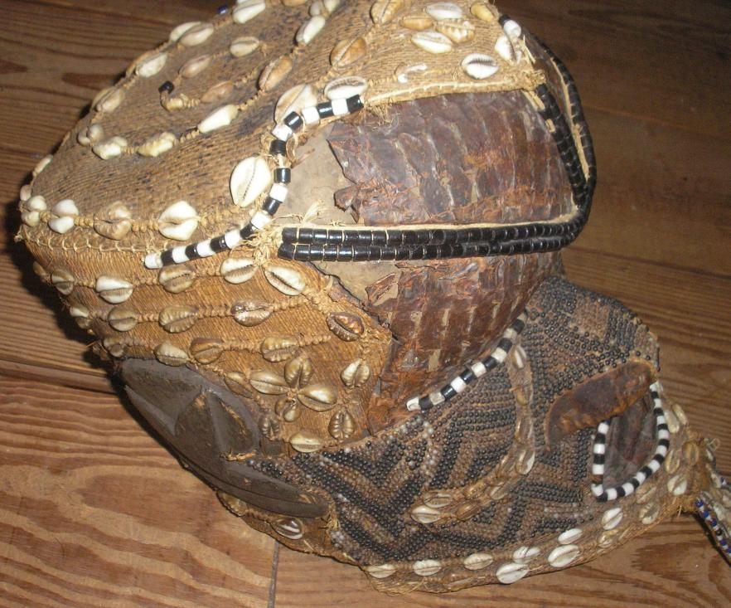

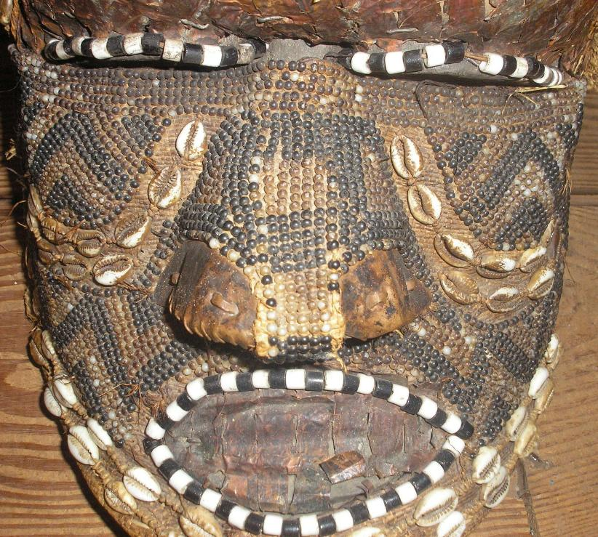

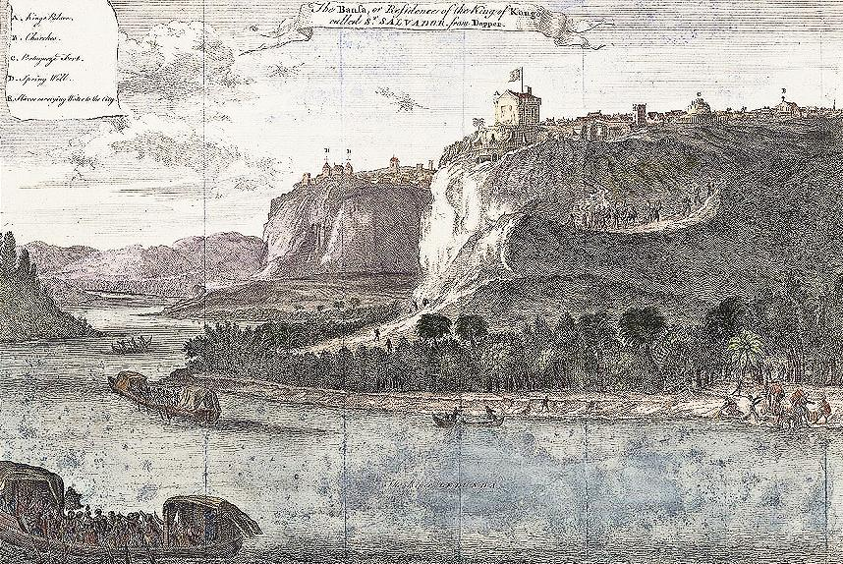

Fig. 2. Mbanza Kongo, “The Bansa or residence of the King of Kongo called Ste. Savadore [by the Portuguese] from [Olfert] Dapper [, *Description de l’Afrique* (Amsterdam: W. Waesberge, Boom et Van Someren, 1686)] where the Kingdom’s medical specialists, nganga or ngang’a n’kisi gathered gathered to assess local pygmy knowledge.

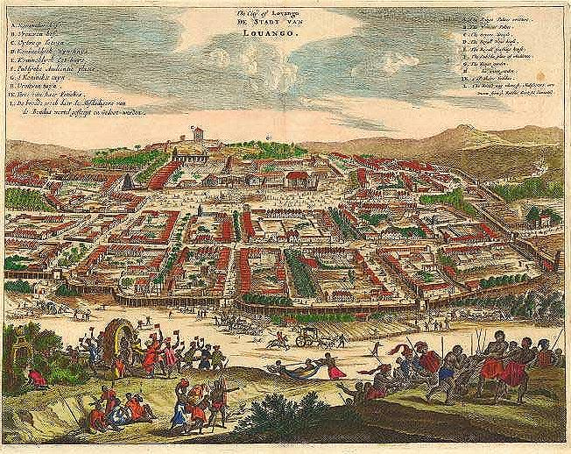

Fig. 3. "The City of Lovango, Der Stadt van Luoango." After Olfert Dapper *Umbständliche und eigentliche Beschreibung von Africa* (Amsterdam, 1670). Another important city of the Kingdom of the Kongo, where medical specialists, *nganga* or *ngang’a n’kisi* gathered to assess local pygmy knowledge.

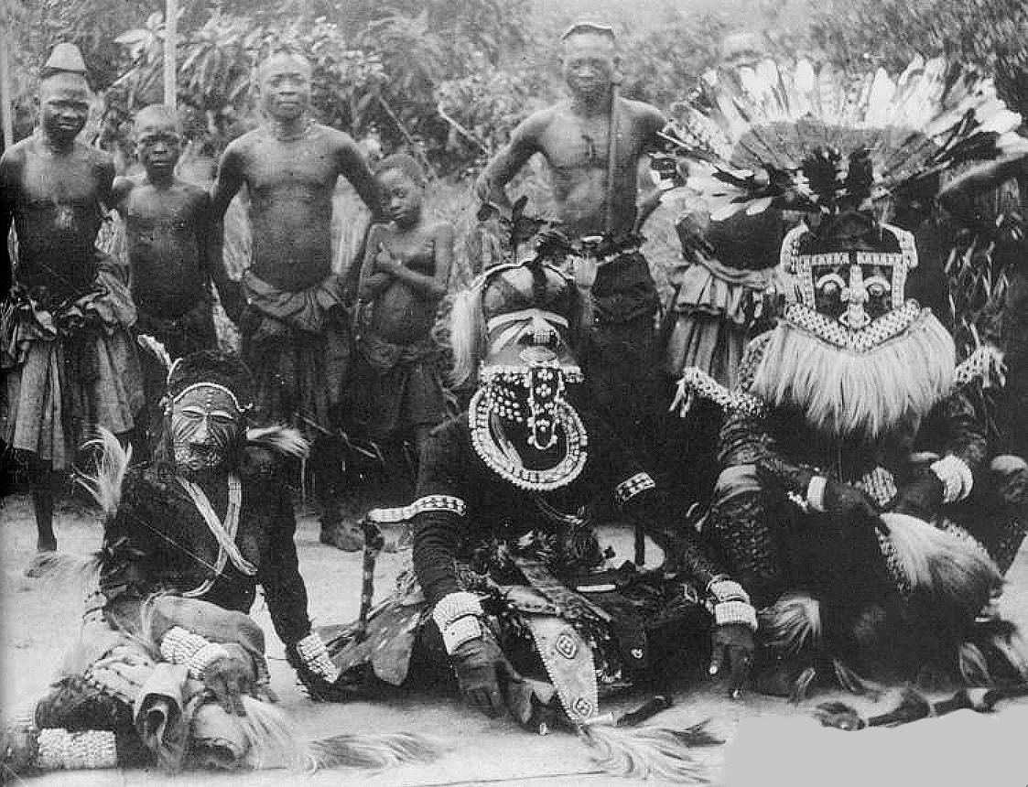

Fig. 4. Kuba masqueraders, Nesheng, southern Kasai River, 1909. Royal Kuba Masqueraders, Nsheng, Kasai, Congo, 1909 (after the Library of the University of Michigan, Image 344206, http://quod.lib.umich.edu/h/hart/x-344206/03d100403). **Bwoom** masquerader, front, center, of hydrocephalic (large-headed) aboriginal pygmy symbolizing profound local knowledge of the forest and its medical riches. Front-center, right: **Mwaash aMbooy**, representing Woot, the founding ancestor of the Kuba. Front–center left: **Ngady Mwaash aMbooy**, the incestuous sister-wife of Woot.

The Kuba people who live in the adjacent Lower Kasai River region visualized this hydrocephalic symbolism in distinctive Bwoom masks with additional symbolic paraphernalia suggesting their ancient origins. In order to incorporate pygmy expert medical knowledge into BaKongo culture, Ntinu Lukeni married the daughter of a local pygmy (?) spiritual leader, Manikabunga, established the town of Mpemba Kasi (near the modern village of Matadi in the Kwilu valley), where the original Kongo Kingdom rulers would be buried, and possibly initiated the tradition of using pygmy medicines (*bilongo*) in conjunction with miN’kisi which may have had their origins with Manikabunga.

In order to economically establish the Kongo Kingdom, Ntinu Lukeni began to charge tolls for passage of traders along the Nzadi River. In order to culturally establish a BaKongo hegemony he required indigenous peoples along the banks of the Nzadi River to speak Kongo, a Bantu language and required his men to marry the daughters of indigenous non-Bantu chiefs.

M*in’kisi* which can take many forms only have an animate being when *bilongo* energize them. *Bilongo* are often in the form of sachets tied to the statuettes and contain ingredients with symbolism that is intended to evoke a desired action.

In addition, the client must also meld ontologically with the *n’kisi,* and this may be accomplished through the application of color symbolism in the form of pigments (often white and red) that metonymically establish a connection between the client, the powerful dead and the *n’kisi* sculpture (MacGaffey 1986: 139-141). Kaolin or white clay (*mpemba*) literally means “land of the dead” or “cemetery.” Kaolin is found in streambeds and corresponds to the belief that “the dead live in or under the water and are white in color” (Van Wing 1941). Another important pigment is red ochre (*nsadi*) “also associated with the dead’ and implies “transition” (Van Wing 1941).

In actual practice, a priest (*nganga* or *nganga’a n’kisi)* acts on behalf of the individual client to prepare the *n’kisi* *bilongo*. Then the client tests the effective potency of the elements in the *bilongo* in actual experience of them with the intermediary of the *nganga* and is cautioned to avoid their powers. At the same time through the actual physical application of red and white pigments the skin, the client establishes a direct connection with the power of the deceased. On the one hand, the effective potency of the bilongo is discouraged, while simultaneously the application of the pigments to the skin establishes the completeness of the *n’kisi* rite (MacGaffey 1986: 141).

References:

Adams, Monni. 1988. 8th century Kuba king figures, *African Art* 21(3): 32-38, 88.

Belepe, Bope. 1974. *Etude socio-morphologique des masques Bwoom des Kuba: Memoire de licence en histoire.* Lubumbashi: Université Nationale du Zaire.

Belepe, Bope. 1981. Les oeuvres plastiques Africaines comme documents d'histoire: Le cas des statues Royales Ndop des Kuba du Zaire, *Africa­Tervuren* 25(1): 9-17.

Binkley, D. 1987. Avatar of power: Southern Kuba masquerade figures in funerary context, *Africa* 57 (1).

Binkley, D. 1990. Masks, space and gender in southern Kuba initiation ritual, *Iowa Studies in Art.* Vol. 3, *Art and Initiation in Zaire.* Iowa City: The University of Iowa.

Brett-Smith, Sarah. 1983. The Doyle Collection of African Art, *Record of the Art Museum, Princeton University,* 42(2), The Doyle Collection of African Art, 2+8-34.

Kuba du Zaire, *Africa­Tervuren 27*(1): 9-17.

Binkley, D. 1987. Avatar of power: Southern Kuba masquerade figures in funerary context, *Africa* 57 (1).

Binkley, D. 1990. Masks, space and gender in southern Kuba initiation ritual, *Iowa Studies in Art.* Vol. 3, *Art and Initiation in Zaire.* Iowa City: The University of Iowa.

Claerhout, A. 1976. Two Kuba wrought-iron statuettes, *African Art* IX (4): 60-64.

Cornet, J. 1972. *Art de l'Afrique Noire au pays du fleuve Zaire*. Brussels: Arcade.

Cornet, J. 1982. *Art royal Kuba.* Milan: Sipiel.

Ehret, Christopher. 2002. *The civilizations of Africa: a history to 1800*. Charlottesville, Virginia: University of Virginia Press.

Forbath, Peter. 1977. *The River Congo*. Boston: Houghton Mifflin.

MacGaffey, Wyatt. 1986. *Religion and society in central Africa: the Bakongo of Lower Zaire*. Chicago: University of Chicago Press.

Rosenwald, J. B. 1974. Kuba king figure, *African Art* VII (3).

Schadeberg, Thilo. 1999. Batwa: the Bantu name for the invisible people, in *Challenging Elusiveness: Central-African Hunter Gatherers in a Multidisciplinary perspective*, ed. K. Beibrouck, S. Elders, and G. Rossel. Leiden: CNWS, 21-39.

Torday, E.. and T. A. Joyce. 1911. Notes ethno­graphiques sur les peuples communement appeles Bakuba, ainsi que sur les peuplades apparentees, les Bushoongo. In *Annales du Musee Royal du Congo Belge, Ethnographie et Anthropologic.,* serie III, tome II, fasc. 1. Brussels: Tervuren.

Vansina, Jan 1955 Initiation Rituals of the Bushong, *Africa* 25(2): 138-153.

Vansina, Jan 1964. *Le royaume kuba.* Tervuren: Musée royal de l'Afrique centrale.

Vansina, Jan 1978. *The children of Woot. A history of the Kuba peoples.* Madison: University of Wisconsin Press/Dawson.

Vansina, Jan 1984. *Art History in Africa.* London: Longman.

Van Wing, Joseph Hubert Leopold. 1941. *Études Bakongo*. II. *Religion et magie*. Institut royal colonial belge. Section des sciences morales et politiques. Mémoires, collection in-8°, t. IX, fasc. 1. Brussels: Desclée de Brouwer.